Periodic Table using File Handling in C Programming Language.

This project is developed using the concept of FILE Handling in C Programming language.
In this project user can edit the data in the file and search the data using any of the property of the element (e.g. atomic number, atomic mass, symbol, name).

SOURCE CODE

// importing header files.
#include<stdio.h>
#include<stdlib.h>
#include<string.h>

// declaring the functions.
void home();
void home2();
void home3();
void home4();
int pass(char*a);
void password1();
void password2();
void showno();
void showmass();
void showname();void showsymbol();
void editno();
void editmass();
void editname();
void editsymbol();

// main function defenition.
int main()
{
// calling home function.
home();
}

// home functon defenition.
// logic : takes input from the user about there preferences.
void home()
{
char a;
printf(" welcome");
printf("\n This is modern periodic table. \n here you can search or edit details about any eliment with the help of \n 1.'atomic no.'\n 2.'atomic mass'\n 3.'name of the element'\n 4.'symbol of ehe element'");
printf("\n\npress 'b' for back! press 'n' for next page! \n" );
scanf(" %c",&a);

if(a=='n')
{
system("cls");
home2();
}
else if(a=='b')
{
system("cls");
password1();
}
else
{
system("cls");
printf("entered reference was wrong!!!!!!!!!!!!!!!!!!!!!!!!!!\n \n \n ");
home();
}
}

// home2 functon defenition.
// logic : takes input from the user about there preferences.
void home2()
{
char a;
getchar();
printf(" CHOSE YOUR CHOICE FROM THE GIVEN DATA \n\n 1. To show the imformation about the element.\n 2. To edit the details of the elememts in the database.\n\n ");
printf("Entre 'b' to go BACK to the home page.\n\n\n\t");
scanf("%c",&a);

if (a =='1')
{
system("cls");
home3();
}
else if(a == '2')
{
system("cls");
password2();
}
else if(a=='b')
{
system("cls");
home();
}
else
{
system("cls");
printf("entered reference was wrong!!!!!!!!!!!!!!!!!!!!! \n\n\n");
home();
}
}

// home3 functon defenition.
// logic : takes input from the user about there preferences.
void home3()
{
char a;
system("cls");
printf("For the display of the data of the elements select the preference you wanted.\n");
printf("\n press - 1 for 'atomic no.'\n press - 2 for 'atomic mass'\n press - 3 for 'name of the element'\n press - 4 for 'symbol of ehe element'\n\n");
printf("Enter 'b' if you want to ga 'BACK'.\n ");
scanf(" %c",&a);

if(a=='1')
{
system("cls");
showno();
}
else if(a=='2')
{
system("cls");
showmass();
}
else if(a=='3')
{
system("cls");
printf("enter the name of the element \n");
showname();
}
else if(a == '4')
{
system("cls");
printf("enter the symbol of the element \n");
showsymbol();
}
else if(a == 'b')
{
system("cls");
home2();
}
else
{
system("cls");
printf("entered reference was wrong!!!!!!!!!!!!!!!!!!!!! \n\n\n");
home();
}
}

// home4 functon defenition.
// logic : takes input from the user about there preferences.
void home4()
{
char a;
system("cls");
printf("For editing select the type of the data you want for searching\n");
printf("\n press - 1 for 'atomic no.'\n press - 2 for 'atomic mass'\n press - 3 for 'name of the element'\n press - 4 for 'symbol of ehe element'\n\n");
printf("Enter 'b' if you want to ga 'BACK'.\n ");
scanf(" %c",&a);

if(a=='1')
{
system("cls");
editno();
}
else if(a=='2')
{
system("cls");
editmass();
}
else if(a=='3')
{
system("cls");
editname();
}
else if(a=='4')
{
system("cls");
editsymbol();
}
else if(a == 'b')
{
system("cls");
home2();
}
else
{
system("cls");
printf("entered reference was wrong!!!!!!!!!!!!!!!!!!!!! \n\n\n");
home();
}
}

// pass functon defenition.
// logic : checks the entered password by the user.
int pass(char *a)
{
char p[2][20]= {"vaibhavgupta",
"vaibhavg"
};
int i,w;
for(i=0;i<2;i++)
{
w=strcmp(p[i],a);
if (w==0)
break;
}
if (w==0)
return 0;
else
return 1;
}

// password1 functon defenition.
// logic : takes input from the user.
void password1()
{
char a[20];
abc:
{
printf(" PLEASE ENTER THE PASSWORD FOR THE DISPLAYING OF THE DATA\n\n ");
scanf("%s",a);
if (pass(a)==0)
{
system("cls");
home();
}
else
{
system("cls");
printf (" !!!!!!!!!!!WRONG PASSWORD !!!!!!!!!!!!!!! \n !!!!!!!!!!!!!!!!!!!!!!!!!!!!!!!!!!!!!!!!!!!\n\n");
}
}
if (pass(a)!=0)
goto abc;
}

// password2 functon defenition.
// logic : takes input from the user.
void password2()
{
char a[20];
printf(" PLEASE ENTER THE PASSWORD TO EDIT THE CONTENTS OF THE SYSTEM FILES.\n\n ");
scanf("%s",a);
if (pass(a)==0)
{
system("cls");
home4();
}
else
{
system("cls");
printf (" !!!!!!!!!!!WRONG PASSWORD !!!!!!!!!!!!!!! \n !!!!!!!!!!!!!!!!!!!!!!!!!!!!!!!!!!!!!!!!!\n\n");
home2();
}
}

void showno()
{
char name[15],sym[3],i;
int no,w;
float mass;
FILE *p;
printf("enter the atomic no.\n ");
scanf("%d",&w);
p=fopen("vaibhavperiodic.txt","r");
while(1)
{
fscanf(p,"%d %s %s %f",&no,name,sym,&mass);
if(no==w)
break;
}
system("cls");
printf(" ATOMIC NO. = '%d'\n NAME OF THE ELEMENT = '%s'\n SYMBOL OF THE ELEMENT = '%s'\n ATOMIC MASS = '%f a.m.u.'\n\n\n",no,name,sym,mass);
printf(" ENTER 'b' TO GO BACK. ENTER 'e' TO EXIT THE PROGRAM.\n\n\t\t\t\t");
scanf("%s",&i);
if (i=='b')
home3();
else if (i=='e')
exit(1);
else
home();
fclose(p);
}

void showmass()
{
char name[15],sym[3],i;
int no,w;
float mass;
FILE *p;
printf("enter the atomic mass \n ");
scanf("%d",&w);
w=w/2;
p=fopen("vaibhavperiodic.txt","r");
while(1)
{
fscanf(p,"%d %s %s %f",&no,name,sym,&mass);
if(no==w)
break;
}
system("cls");
printf(" ATOMIC NO. = '%d'\n NAME OF THE ELEMENT = '%s'\n SYMBOL OF THE ELEMENT = '%s'\n ATOMIC MASS = '%f a.m.u.'\n\n\n",no,name,sym,mass);
printf(" ENTER 'b' TO GO BACK. ENTER 'e' TO EXIT THE PROGRAM.\n\n\t\t\t\t");
scanf("%s",&i);
if (i=='b')
home3();
else if (i=='e')
exit(1);
else
home();
fclose(p);
}

void showname()
{
char i,q[15],name[15],sym[3];
int no;
float mass;
FILE *p;
scanf("%s",q);
p=fopen("vaibhavperiodic.txt","r");
while(1)
{
fscanf(p,"%d %s %s %f",&no,name,sym,&mass);
if((strcmpi(q,name)==0))
break;
}
system("cls");
printf(" ATOMIC NO. = '%d'\n NAME OF THE ELEMENT = '%s'\n SYMBOL OF THE ELEMENT = '%s'\n ATOMIC MASS = '%f a.m.u.'\n\n\n",no,name,sym,mass);
printf(" ENTER 'b' TO GO BACK. ENTER 'e' TO EXIT THE PROGRAM.\n\n\t\t\t\t");
scanf("%s",&i);
if (i=='b')
home3();
else if (i=='e')
exit(1);
else
home();
fclose(p);
}

void showsymbol()
{
char i,q[3],name[15],sym[3];
int no;
float mass;
FILE *p;
scanf("%s",q);
p=fopen("vaibhavperiodic.txt","r");
while(1)
{
fscanf(p,"%d %s %s %f",&no,name,sym,&mass);
if(strcmpi(q,sym)==0)
break;
}
system("cls");
printf(" ATOMIC NO. = '%d'\n NAME OF THE ELEMENT = '%s'\n SYMBOL OF THE ELEMENT = '%s'\n ATOMIC MASS = '%f a.m.u.'\n\n\n",no,name,sym,mass);
printf(" ENTER 'b' TO GO BACK. ENTER 'e' TO EXIT THE PROGRAM.\n\n\t\t\t\t");
scanf("%s",&i);
if (i=='b')
home3();
else if (i=='e')
exit(1);
else
home();
fclose(p);
}

void editno()
{
char name[15],sym[3],a,i,q;
int no,w;
float mass;
FILE *p;
FILE *np;
p=fopen("vaibhavperiodic.txt","r");
np=fopen("vaibhavperiodic_temp.txt","w");
printf("ENTER THE ATOMIC NO. OF THE ELEMENT =\n\t");
scanf("%d",&w);
while(!feof(p))
{
fscanf(p,"%d %s %s %f ",&no,name,sym,&mass);
if(no==w)
{
printf("\n\t\tEnter the corresponding data background you wand to edit : \n\n");
abc:
{
printf(" press - 1 for 'atomic no.'\n press - 2 for 'atomic mass'\n press - 3 for 'name of the element'\n press - 4 for 'symbol of ehe element'\n\n\t");
scanf(" %c",&q);
if(q=='1')
{
printf("\n ATOMIC NO. = ");
scanf("%d",&no);
}
else if(q=='2')
{
printf("\n ATOMIC MASS = ");
scanf("%f",&mass);
}
else if(q=='3')
{
printf("\n NAME OF THE ELEMENT = ");
scanf("%s",name);
}
else if(q == '4')
{
printf("\n SYMBOL OF THE ELEMENT = ");
scanf("%s",sym);
}
}
printf("\n\n\t\tdo you want to edit more details,or re-enter the last details Y/N\n\n\t");
getchar();
scanf("%c",&a);
if(a=='y'||a=='Y')
goto abc;
else if(a=='N'||a=='n')
fprintf(np,"%d %s %s %f\n",no,name,sym,mass);
else
home();
}
else
fprintf(np,"%d %s %s %f\n",no,name,sym,mass);
}
fclose(p);
fclose(np);
remove("vaibhavperiodic.txt");
rename("vaibhavperiodic_temp.txt","vaibhavperiodic.txt");
printf("\n\n ENTER 'b' TO GO BACK. ENTER 'e' TO EXIT THE PROGRAM.\n\n\t\t\t\t");
scanf("%s",&i);
if (i=='b')
home3();
else if (i=='e')
exit(1);
else
home();
}

void editmass()
{
char name[15],sym[3],i,q,a;
int no,w;
float mass;
FILE *p;
FILE *np;
printf("ENTER THE ATOMIC MASS OF THE ELEMENT = \n");
scanf("%d",&w);
w=w/2;
p=fopen("vaibhavperiodic.txt","r");
np=fopen("vaibhavperiodic_temp.txt","w");
while(!feof(p))
{
fscanf(p,"%d %s %s %f ",&no,name,sym,&mass);
if(no==w)
{
printf("\n\t\tEnter the corresponding data background you wand to edit : \n\n");
abc:
{
printf(" press - 1 for 'atomic no.'\n press - 2 for 'atomic mass'\n press - 3 for 'name of the element'\n press - 4 for 'symbol of ehe element'\n\n\t");
scanf(" %c",&q);
if(q=='1')
{
printf("\n ATOMIC NO. = ");
scanf("%d",&no);
}
else if(q=='2')
{
printf("\n ATOMIC MASS = ");
scanf("%f",&mass);
}
else if(q=='3')
{
printf("\n NAME OF THE ELEMENT = ");
scanf("%s",name);
}
else if(q == '4')
{
printf("\n SYMBOL OF THE ELEMENT = ");
scanf("%s",sym);
}
}
printf("\n\n\t\tdo you want to edit more details,or re-enter the last details Y/N\n\n\t");
getchar();
scanf("%c",&a);
if(a=='y'||a=='Y')
goto abc;
else if(a=='N'||a=='n')
fprintf(np,"%d %s %s %f\n",no,name,sym,mass);
else
home();
}
else
fprintf(np,"%d %s %s %f\n",no,name,sym,mass);
}
fclose(p);
fclose(np);
remove("vaibhavperiodic.txt");
rename("vaibhavperiodic_temp.txt","vaibhavperiodic.txt");
printf("\n\n ENTER 'b' TO GO BACK. ENTER 'e' TO EXIT THE PROGRAM.\n\n\t\t\t\t");
getchar();
scanf("%s",&i);
if (i=='b')
home3();
else if (i=='e')
exit(1);
else
home();
}

void editname()
{
char name[15],sym[3],i,w[15],q,a;
int no;
float mass;
FILE *p;
FILE *np;
printf("ENTER THE NAME OF THE ELEMENT = \n");
scanf("%s",w);
p=fopen("vaibhavperiodic.txt","r");
np=fopen("vaibhavperiodic_temp.txt","w");
while(!feof(p))
{
fscanf(p,"%d %s %s %f ",&no,name,sym,&mass);
if(strcmpi(w,name)==0)
{
printf("\n\t\tEnter the corresponding data background you wand to edit : \n\n");
abc:
{
printf(" press - 1 for 'atomic no.'\n press - 2 for 'atomic mass'\n press - 3 for 'name of the element'\n press - 4 for 'symbol of ehe element'\n\n\t");
scanf(" %c",&q);
if(q=='1')
{
printf("\n ATOMIC NO. = ");
scanf("%d",&no);
}
else if(q=='2')
{
printf("\n ATOMIC MASS = ");
scanf("%f",&mass);
}
else if(q=='3')
{
printf("\n NAME OF THE ELEMENT = ");
scanf("%s",name);
}
else if(q == '4')
{
printf("\n SYMBOL OF THE ELEMENT = ");
scanf("%s",sym);
}
}
printf("\n\n\t\tdo you want to edit more details,or re-enter the last details Y/N\n\n\t");
getchar();
scanf("%c",&a);
if(a=='y'||a=='Y')
goto abc;
else if(a=='N'||a=='n')
fprintf(np,"%d %s %s %f\n",no,name,sym,mass);
else
home();
}
else
fprintf(np,"%d %s %s %f\n",no,name,sym,mass);
}
fclose(p);
fclose(np);
remove("vaibhavperiodic.txt");
rename("vaibhavperiodic_temp.txt","vaibhavperiodic.txt");
printf("\n\n ENTER 'b' TO GO BACK. ENTER 'e' TO EXIT THE PROGRAM.\n\n\t\t\t\t");
scanf("%s",&i);
if (i=='b')
home3();
else if (i=='e')
exit(1);
else
home();
}

void editsymbol()
{
char name[15],sym[3],i,w[3],q,a;
int no;
float mass;
FILE *p;
FILE *np;
printf("ENTER THE SYMBOL OF THE ELEMENT = \n");
scanf("%s",w);
p=fopen("vaibhavperiodic.txt","r");
np=fopen("vaibhavperiodic_temp.txt","w");
while(!feof(p))
{
fscanf(p,"%d %s %s %f ",&no,name,sym,&mass);
if(strcmpi(w,sym)==0)
{
printf("\n\t\tEnter the corresponding data background you wand to edit : \n\n");
abc:
{
printf(" press - 1 for 'atomic no.'\n press - 2 for 'atomic mass'\n press - 3 for 'name of the element'\n press - 4 for 'symbol of ehe element'\n\n\t");
scanf(" %c",&q);
if(q=='1')
{
printf("\n ATOMIC NO. = ");
scanf("%d",&no);
}
else if(q=='2')
{
printf("\n ATOMIC MASS = ");
scanf("%f",&mass);
}
else if(q=='3')
{
printf("\n NAME OF THE ELEMENT = ");
scanf("%s",name);
}
else if(q == '4')
{
printf("\n SYMBOL OF THE ELEMENT = ");
scanf("%s",sym);
}
}
printf("\n\n\t\tdo you want to edit more details,or re-enter the last details Y/N\n\n\t");
getchar();
scanf("%c",&a);
if(a=='y'||a=='Y')
goto abc;
else if(a=='N'||a=='n')
fprintf(np,"%d %s %s %f\n",no,name,sym,mass);
else
home();
}
else
fprintf(np,"%d %s %s %f\n",no,name,sym,mass);
}
fclose(p);
fclose(np);
remove("vaibhavperiodic.txt");
rename("vaibhavperiodic_temp.txt","vaibhavperiodic.txt");
printf("\n\n ENTER 'b' TO GO BACK. ENTER 'e' TO EXIT THE PROGRAM.\n\n\t\t\t\t");
scanf("%s",&i);
if (i=='b')
home3();
else if (i=='e')
exit(1);
else
home();
}

OUTPUT
MAIN HOME PAGE
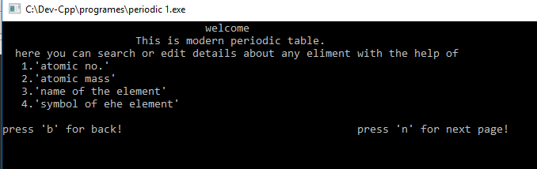
CHOOSING FROM DISPLAYING AND
EDITING
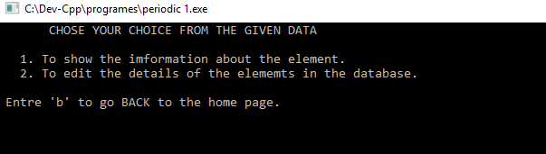
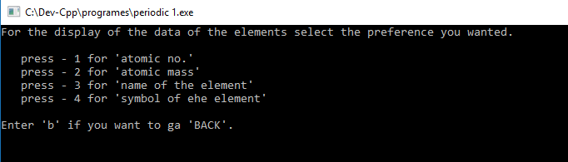
DISPLAYING

DISPLAYING THE DATA OF
NITROGEN WITH (ATOMIC NO.7)
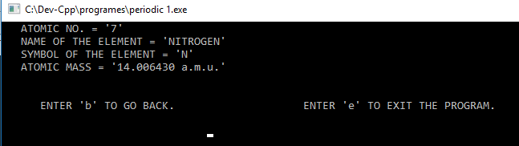
EDITING THE DATA
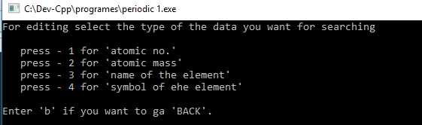

EDITING THE DETAILS FOR NITROGEN
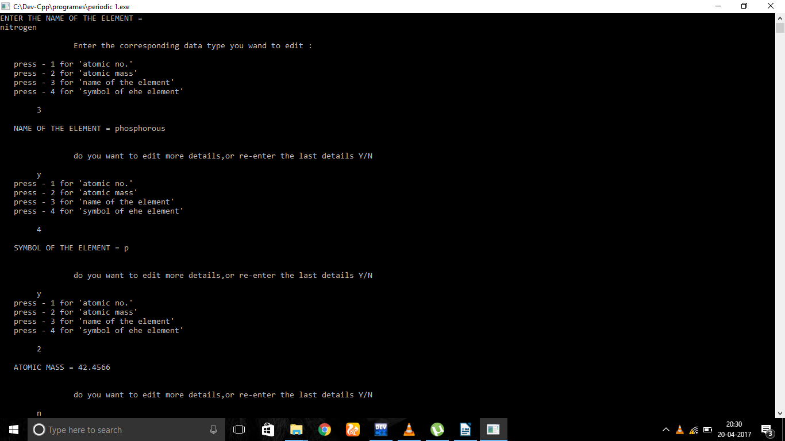

NEW OUTPUT AFTER EDITING THE DETAILS FOR NITROGEN.

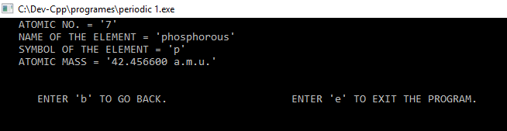

DATA IN THE FILE

1 HYDROGEN H 1.01
2 HELIUM He 4.02
3 LITHIUM Hi 6.936
4 BERYLLIUM Be 9.0121
5 BORON B 10.806
6 CARBON C 12.0096
7 NITROGEN N 14.00643
8 OXYGEN O 15.99903
9 FLUORINE F 18.9984
10 NEON Ne 20.1797
11 SODIUM Na 22.9897
12 MAGNESIUM Mg 24.304
13 ALUMINIUM Al 26.9815
14 SILICON Si 28.084
15 PHOSPHOROUS P 30.9737
16 SULPHUR S 32.059
17 CHLORINE Cl 35.446
18 ARGON Ar 39.948
19 POTASSIUM K 39.0983
20 CALCIUM Ca 40.078
21 SCANDIUM Sc 44.9559
22 TITANIUM Ti 47.867
23 VANADIUM V 50.9415
24 CHROMIUM Cr 51.9961
25 MANGANESE Mn 54.938045
26 IRON Fe 55.845
27 COBALT Co 58.993
28 NICKEL Ni 58.693
29 COPPER Cu 63.546
30 ZINC Zn 65.38
31 GALLIUM Ga 69.723
32 GERMANIUM Ge 72.630
33 ARSENIC As 74.9215
34 SELENIUM Se 78.971
35 BROMINE Br 79.901
36 KRYPTON Kr 83.798
37 RUBIDIUM Rb 85.4678
38 STRONTIUM Sr 87.62
39 YTTRIUM Y 88.9058
40 ZIRCONIUM Zr 91.224
41 NIOBIUM Nb 92.9063
42 MOLYBDENUM Mo 95.95
43 TECHNETIUM Tc 98.05
44 RUTHENIUM Ru 101.0
45 RHODIUM Rh 102.9055
46 PALLADIUM Pd 106.42
47 SILVER Ag 107.8682
48 CADMIUM Cd 112.414
49 INDIUM In 114.818
50 TIN Sn 118.701
51 ANTIMONY Sb 121.760
52 TELLURIUM Te 127.60
53 IODINE I 126.9044
54 XENON Xe 131.293
55 CAESIUM Cs 132.90545
56 BARIUM Ba 137.327
57 LANTHANUM La 138.9054
58 CERIUM Ce 140.116
59 PRASEODYMIUM Pr 140.90766
60 NEODYMIUM Nd 144.242

